Edward J. Jaselskis

North Carolina State University

Centennial Campus Box 8601

Raleigh, NC

**NCDOT Project TT 2025-03**

**March 2025**

**TRANSFERRING NCDOT’S NEW RISK INSIGHT TOOL AND RISK MANAGEMENT PLAYBOOK TO PRACTICE**

|  |  |  |  |  |  |
| --- | --- | --- | --- | --- | --- |
| 1. Report No.   FHWA/NC/TT-2025-03 | 1. Government Accession No. | | 1. Recipient’s Catalog No. | | |
| 1. Title and Subtitle   Transferring NCDOT’s New Risk Insight Tool and Risk Management Playbook to Practice | | | 1. Report Date   March 28, 2025 | | |
| 1. Author(s)   Edward J. Jaselskis | | | 1. Performing Organization Code | | |
| 1. Performing Organization Report No. | | |
| 1. Performing Organization Name and Address   North Carolina State University  Centennial Campus Box 8601  Raleigh, NC | | | 1. Work Unit No. (TRAIS) | | |
| 1. Contract or Grant No. | | |
| 1. Sponsoring Agency Name and Address   North Carolina Department of Transportation  Research and Analysis Group  104 Fayetteville Street  Raleigh, North Carolina 27601 | | | 1. Type of Report and Period Covered  |  | | --- | | Final Report  May 15, 2024 to September 30, 2024 | | | |
| 1. Sponsoring Agency Code   TT 2025-03 | | |
| Supplementary Notes: | | | | | |
| 1. Abstract   This technology transfer project is part of an effort by the NCDOT’s Value Management Office to further advance its current risk management program by promoting new risk profiling tools to help identify project risks and mitigation strategies. A previous North Carolina State University (NCSU) research project (Jaselskis and Gholami 2023), conducted by the principal investigator, examined past claims and supplemental agreements for different project types to better understand the risk profiles for various projects (e.g., rural, urban, and bridge replacement). That work resulted in the Excel-based Risk Insight Tool (RIT) and Risk Management Playbook (RMP), which provide valuable risk insights and mitigation strategies to support project managers and their teams as they perform risk assessments. This technology transfer project aims to ensure both the usability and implementation of the RIT and RMP by considering their refinement through consolidation and further insights gleaned from analysis of additional claims and supplemental agreements. By combining the RIT and RMP legacy versions, the NCSU research team has developed a new Excel-based Risk Management Tool. (RMT) as well as a new Excel-based Design Risk Tool (DRT) to identify common design errors and omissions that can lead to claims and supplemental agreements during the construction phase. The team also developed an integrated and more streamlined version of the new RMT and DRT using Power BI (Integrated Risk Management Tool, I-RMT). Future research can explore ways to broaden the use of these newly created tools to assist NCDOT teams with project risk assessment. | | | | | |
| 1. Keywords   Risk management, risk assessment and mitigation, risk identification | | | | 1. Distribution Statement | |
| 1. Security Classif. (of this report)   Unclassified | | 1. Security Classif. (of this page)   Unclassified | | | 1. No. of Pages   28 Pages |
| Form DOT F 1700.7 (8-72) Reproduction of completed page authorized | | | | | |

**Technical Report Documentation Page**

# DISCLAIMER

The views expressed in this report are the author’s own and may not necessarily reflect those of North Carolina State University. The authors are responsible for ensuring the accuracy of the information and data presented. It should be noted that the official views or policies of the North Carolina Department of Transportation at the time of publication may differ from those presented in this report. Additionally, this report should not be considered as a standard, specification, or regulation.

# EXECUTIVE SUMMARY

The effective implementation of risk management practices is acknowledged by state departments of transportation (DOTs) to achieve favorable outcomes for transportation projects. Many state DOTs have developed various tools to assist project managers in their risk management efforts. In line with this work, the North Carolina Department of Transportation (NCDOT) initiated a collaborative effort through its Value Management Office (VMO) with North Carolina State University (NCSU) to identify opportunities for enhancing the NCDOT's existing risk management program. Consequently, in earlier research (Jaselskis and Leca, 2019), NCSU researchers conducted a comprehensive examination of the NCDOT's risk management program and that of other DOTs, which led to identified areas for suggested improvements.

This technology transfer project is part of an effort by the NCDOT’s VMO to further advance its current risk management program by promoting new risk profiling tools that can help identify project risks and mitigation strategies. A previous NCSU/NCDOT research project (Jaselskis and Gholami 2023), conducted by the principal investigator, examined past claims and supplemental agreements for different NCDOT project types to better understand the risk profiles for various projects (e.g., rural, urban, and bridge replacement). That work resulted in the Excel-based Risk Insight Tool (RIT) and Risk Management Playbook (RMP), which provide valuable risk insights and mitigation strategies to support project managers and their teams as they perform risk assessments. This technology transfer project aims to ensure both the usability and implementation of these two tools by considering the development of a suitable ‘how to’ guide that may be in the form of standard operating procedures and/or training materials to maximize benefits for the NCDOT.

To that end, this technology transfer effort involved the development of a new Excel-based Risk Management Tool (RMT) that combines key aspects of the RIT and RMP (also called legacy versions), thereby providing a one-package solution that includes both project risk insights as well as mitigation strategies. The new RMT is intended to serve as the ‘how to’ guide for understanding and addressing risks on NCDOT projects. The RMT software includes detailed instructions to provide clear user guidance. Additionally, the NCSU research team analyzed approximately 1,800 new claims and supplemental agreement data to gain further insights that relate to more recent discipline-related design/plan issues (e.g., ROW, utilities, and hydraulics) as well as other problems often faced on transportation projects. Design/plan issues are the main cause of problems that arise during the construction phase. The analysis of the claims and supplemental agreement data allowed for the creation of a new tool called the Design Risk Tool (DRT), also based on Excel. The DRT should be of particular interest to the various design groups within the NCDOT to proactively identify potential design errors and omissions before construction begins. Claims and supplemental agreement summaries in the DRT are also provided in the RMT. The limited sample of project managers who reviewed these materials provided positive feedback on both the new RMT and DRT. Another positive outcome of this project is a compact version of the RMT and DRT created in Power BI, Integrated-Risk Management Tool (I-RMT), which facilitates and streamlines the gathering of risk information for users. I-RMT can be viewed directly using the Power BI Desktop (free download) or through the Power BI Service once the necessary workspace is created.

Further research can explore ways to broaden the use of these newly created tools, such as integration with the NCDOT’s Risk Assessment Worksheet and/or adoption of artificial intelligence to create a risk identification/mitigation chatbot that is fine-tuned to NCDOT projects. Additional user feedback can be obtained to better understand user preferences regarding ways these newly developed tools should best be implemented.

**TABLE OF CONTENTS**

DISCLAIMER iii

EXECUTIVE SUMMARY iv

LIST OF FIGURES 7

1 INTRODUCTION 8

1.1 Technology Transfer Objectives 9

1.2 Methodology 9

2 RISK MANAGEMENT TOOL (RMT) 10

2.1 RMT Description 10

2.2 Use Cases 16

3 DESIGN RISK TOOL (DRT) 17

3.1 DRT Description 17

3.2 Summaries of Design/Plan and Other Issues 19

3.3 Use Cases 24

4 FEEDBACK 24

5 POWER BI VERSION OF THE NEW RMT AND DRT 24

6 SUMMARY AND CONCLUSION 26

7 REFERENCES 28

# LIST OF FIGURES

Figure 1. Risk technology transfer methodology tasks…………………………….…………….. 9

Figure 2. Risk Management Tool cover tab ……………………………………..……………… 11

Figure 3. Description of generic and specific causes for claims and

supplemental agreements ……………………………………………………………………… 12

Figure 4. Description of claims for all projects types …………..……………………………… 13

Figure 5. Description of supplemental agreements for all project types ………………………. 14

Figure 6. Description of design/plan issues for claims and supplemental agreements …………. 15

Figure 7. Utilities risk mitigation strategies ………..…………………………………………… 16

Figure 8. Design Risk Tool: All design risks (Level 1) ……………………...………………… 17

Figure 9. Design Risk Tool: Pavement design (Level 2) …………………….…………………. 18

Figure 10. Design Risk Tool: Pavement design (Level 3) …….……….……..………………… 19

Figure 11. Percentages of design/plan issues for claims and supplemental agreements ……..… 20

Figure 12. Costs of design/plan issues for claims and supplemental agreements

($/occurrence) …………………………………………….……………………………………. 20

Figure 13. Introduction to the Integrated Risk Management Tool (I-RMT) ……………………. 25

Figure 14. I-RMT: Generic Causes with slicers by category and project type …………………. 25

Figure 15. I-RMT: Discipline area breakdown showing average cost and time …….…………. 26

Figure 16. Progression of risk tool development …………………………………….…………. 26

# INTRODUCTION

The construction industry plays an integral role in infrastructure development and societal progress, making it a primary sector for governments to allocate significant financial resources (U.S. Census Bureau 2023, Ofori 2022). As of March 2023, the United States Census Bureau Monthly Construction Report reported a seasonally adjusted value of $399.6 billion for construction in the public construction sector (U.S. Census Bureau 2023). Yet, construction projects rarely meet their allocated budget and timelines because they are continuously confronted with risks (Herra et al. 2020). Given the multitude of challenges that departments of transportation (DOTs) face, implementing a formal approach to risk management is the most effective method to identify numerous potential risk events, systematically analyze those risks, and understand their interrelationships that ultimately highlight the most critical risks (U.S. Department of Energy 2003). Therefore, the process of risk management entails the identification and analysis of potential risks, followed by the determination of suitable responses (Project Management Institute 2017, FHWA 2016). This approach allows the project team to gain control over uncertainties and adopt a proactive stance rather than reacting to problems as they arise. Brainstorming, case-based approaches, and checklists are among the commonly employed tools and techniques for risk management, especially during the risk identification and response stages (Siraj et al., 2019, Maytorena et al. 2007).

This technology transfer project provides improvements to and expansion of the North Carolina Department of Transportation’s (NCDOT’s) current risk assessment program that is housed within the NCDOT’s Value Management Office (VMO). The VMO oversees five programs that together focus on “enhancing project delivery at every phase of a project’s life.” (NCDOT 2025). The Risk Assessment Program is one of these five programs that identifies potential risks associated with a construction project and develops a plan to reduce those risks. The effective implementation of risk management practices is acknowledged by state departments of transportation (DOTs) to achieve favorable outcomes for transportation projects. Many state DOTs have developed various tools to assist project managers in their risk management efforts. In line with this work, the NCDOT initiated a collaborative effort through its VMO with North Carolina State University (NCSU) to identify opportunities for enhancing the NCDOT's existing risk management program. Consequently, NCSU researchers conducted a comprehensive examination of the NCDOT's risk management program and that of other DOTs, which led to identified areas for suggested improvements. This technology transfer project is a continuation of the NCDOT’s VMO research collaborative effort with NCSU to further advance its current risk management program by promoting new risk profiling tools that help identify project risks and mitigation strategies.

A previous NCSU/NCDOT research project (Jaselskis and Gholami 2023), conducted by the principal investigator, examined past claims and supplemental agreements for different project types to better understand the risk profiles for various types of projects (e.g., rural, urban, and bridge replacement). That work resulted in the Excel-based Risk Insight Tool (RIT) and Risk Management Playbook (RMP), which have provided valuable risk insights and mitigation strategies to support project managers and their teams as they perform risk assessments. This technology transfer project aims to ensure both the usability and implementation of these two tools by considering the development of a suitable ‘how to’ guide, which may be in the form of standard operating procedures and/or training materials to maximize the benefits gained by the NCDOT. This work has led a more streamlined version of the previously developed RIT and RMP, Risk Management Tool (RMT), which includes a description of the risk assessment process starting with becoming familiar with risks on NCDOT projects (Step 1), identifying risks by project type (Step 2), and identifying risk mitigation strategies (Step 3). A new Design Risk Tool was also created using newer claims and supplemental agreements (2021-2023). As an added bonus, a Power BI version of these risk tools was developed. These software tools essentially provide the ‘how to’ guidance to the teams as they perform project risk assessments.

## Technology Transfer Objectives

The main objectives of this technology transfer project are to:

* Demonstrate the RIT and RMP to project managers, obtain their feedback, and make slight modifications to the tools, as necessary.
* Analyze more recent (past three years) claims and supplemental agreement data and report any changes from the risk insight trends found from the RIT (between 1993 and 2021).
* Develop a ‘how to’ guide that may consist of standard operating procedures and/or training materials for promoting these important tools.

## Methodology

Figure 1 presents the three tasks of the methodology employed for this technology transfer project. By combining key aspects of the RIT and RMP legacy versions, the methodology develops a new tool, the Risk Management Tool (RMT), thus creating a one-stop software solution that provides both project risk insights as well as mitigation strategies. This new tool is intended to serve as the ‘how to’ guide for understanding risks on NCDOT projects (Task 1). Task 2 involves analyzing newer claim and supplemental agreement data from the previous three years to offer further risk insights that can be integrated into the RIT and RMP (note that RIT trends are based on data from 1993-2021). For the technology transfer project, the NCSU research team analyzed newer data from HICAMS using a similar content and data analysis approach that was taken in the previous study (Jaselskis and Gholami 2023). This Task 2 effort led to the development of the Design Risk Tool (DRT) that provides insights into design issues that can lead to claims and supplemental agreements. Task 3 involves obtaining feedback from users and making any necessary modifications.



**Figure 1. Risk technology transfer methodology tasks.**

# RISK MANAGEMENT TOOL (RMT)

The newly developed RMT is a comprehensive Excel-based software product that offers project managers and their teams a structured approach to identifying and mitigating potential risks, thus leading to better risk management outcomes. The RMT combines key information from the legacy RIT and RMP while streamlining some of the details. The RMT provides risk insights for several project categories (e.g., Interstate, Ferry, Rest Area, and Urban) and is based on data obtained from recent NCDOT claims and supplemental agreements. The RMT also provides mitigation strategies for the six critical areas of transportation projects: Roadway, Right-of-Way, Structures, Utilities, Rail, and Other. The RMT can be used to assist NCDOT project management teams in identifying potential risks as well as cost and schedule impacts during the project planning, design, and construction phases and can assist personnel in performing risk assessments and completing the NCDOT’s Risk Assessment Worksheet (RAW).

## RMT Description

The RMT contains several tabs, beginning with a description of overall project Risk Areas and Design/Plan issues commonly found in transportation projects (Tab 1). A summary of all NCDOT claims and supplemental agreements is provided and shows the percentages of the occurrence of specific risks as well as their cost and schedule impacts (Tabs 2a and 2b, respectively). Tabs 3a and 3b provide descriptions of NCDOT Design/Plan issues and Other issues, respectively. Tabs 4a/4b through 16a/16b (‘a’ is for claims and ‘b’ is for supplemental agreements) provide breakdowns of the claims and supplemental agreements by project type (e.g., Urban, Interstate, Rural, and Ferry). Tabs 17a. through 17f show the mitigation strategies. Figure 2 is an image of the cover tab that provides an introduction to the RMT and its three-step process.

Step 1: Become familiar with risks on NCDOT projects.

Step 2: Identify risks by project type.

Step 3: Identify risk mitigation strategies.

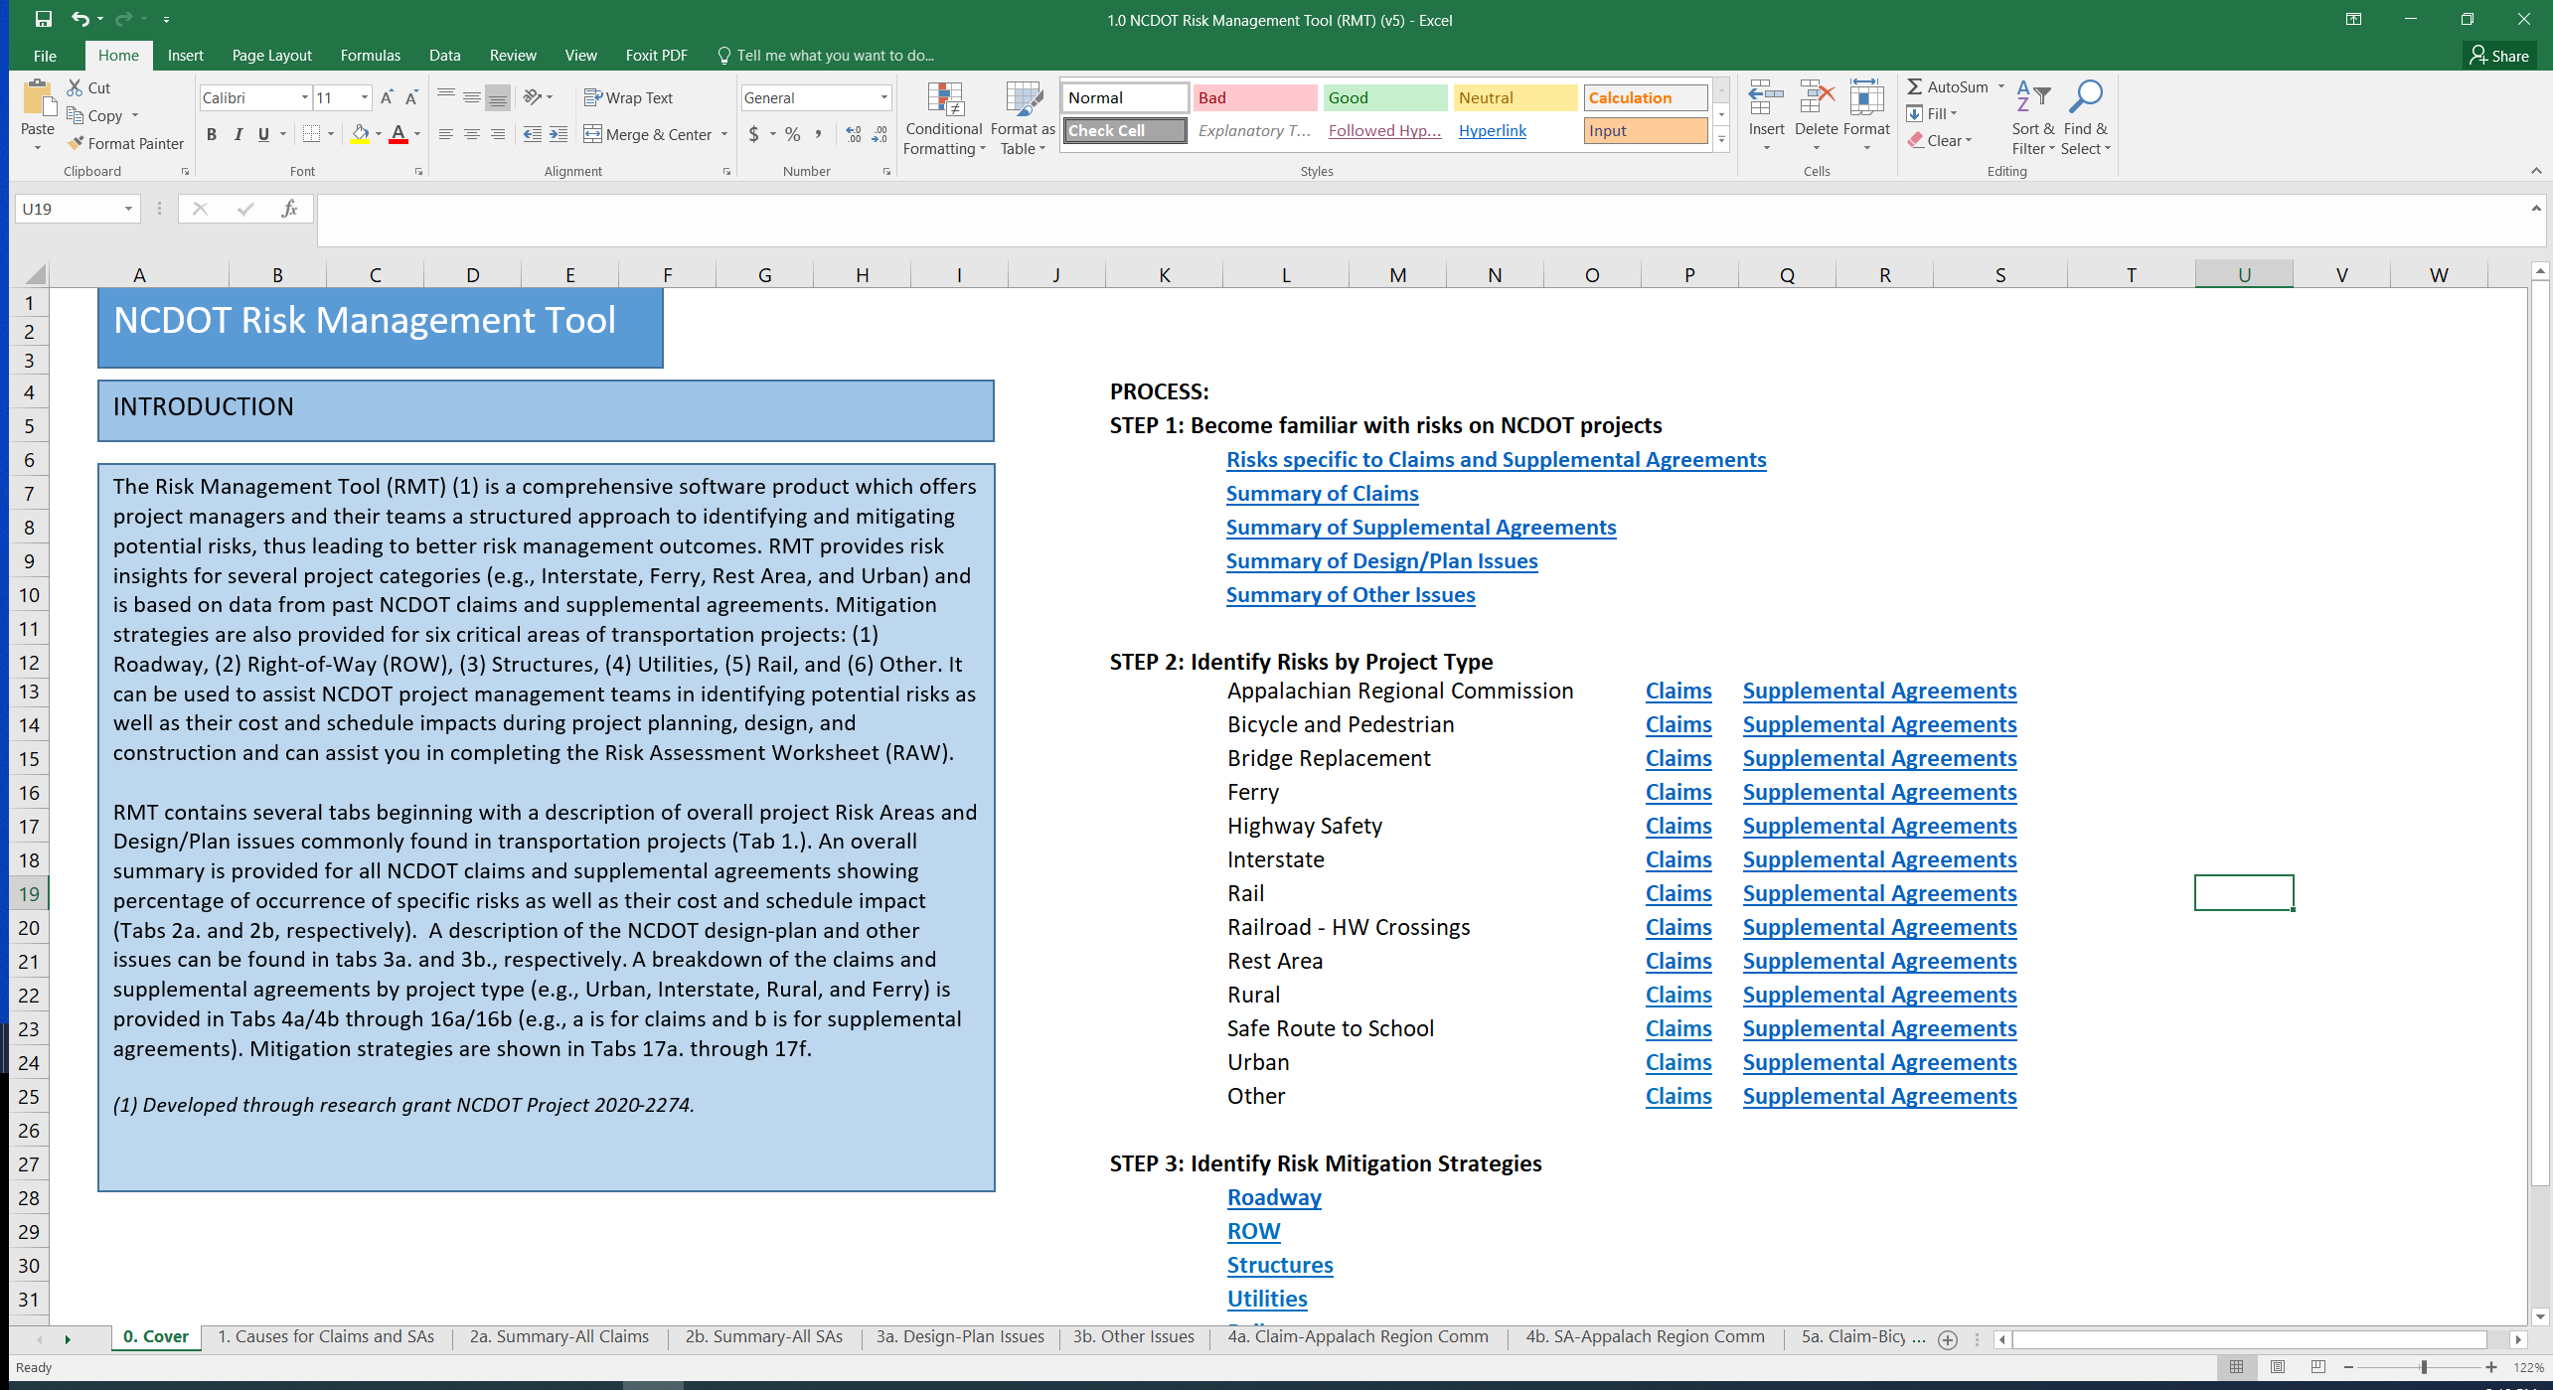

**Figure 2. Risk Management Tool cover tab.**

Figure 3 provides a description of generic and specific causes for claims and supplemental agreements. Note that many of the causes are the same for both claims and supplemental agreements (e.g., Design/Plan Issues) while others are unique to each category, such as claims (e.g., Natural Disaster: Unforeseen natural disasters such as hurricanes, tornados, and floods that impact project progress and completion).

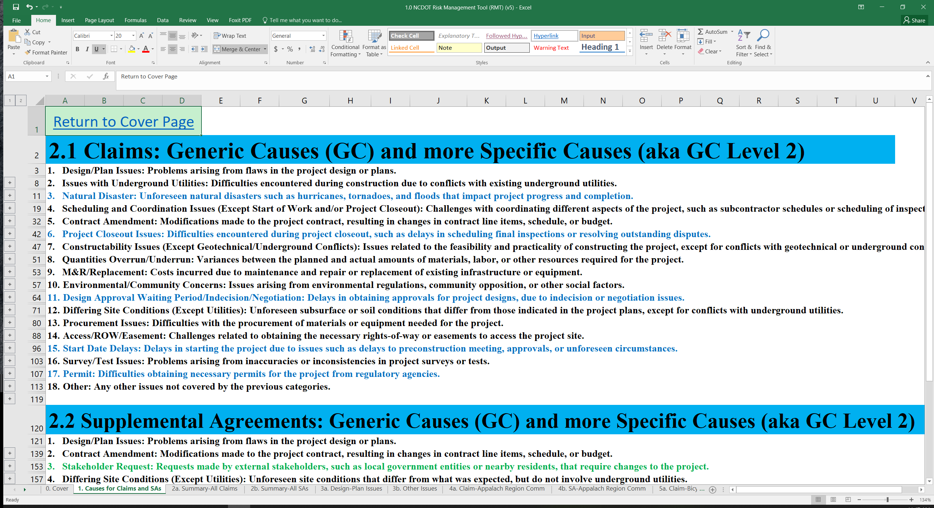

**Figure 3. Description of generic and specific causes for claims and supplemental agreements.**

Figure 4 offers a description of claims for All Project Types. Note that hurricanes were the cause for most (94.3%) of the claims related to natural disasters. Utility conflicts were the main cause for claims related to Issues with Underground Utilities.

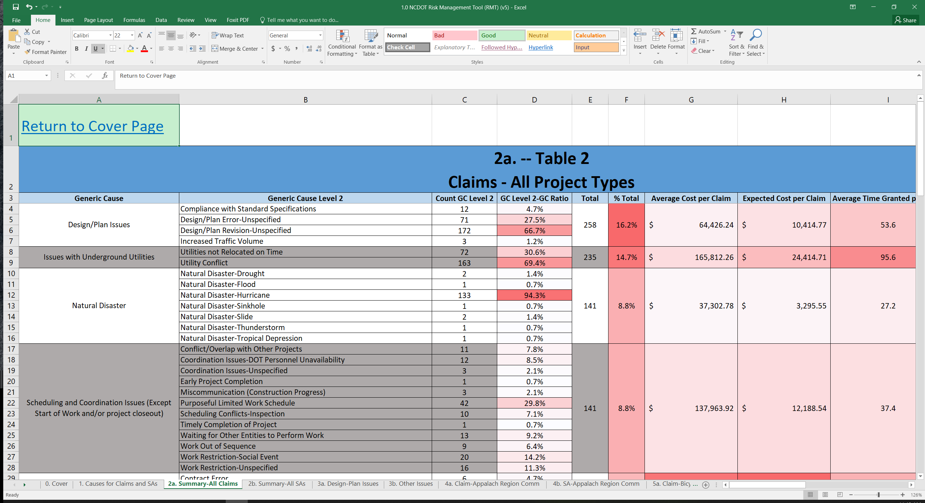

**Figure 4. Description of claims for all project types.**

Figure 5. presents the main causes for supplemental agreements for All Project Types and indicates that Line Item Omissions were the main reason for Contract Amendments.

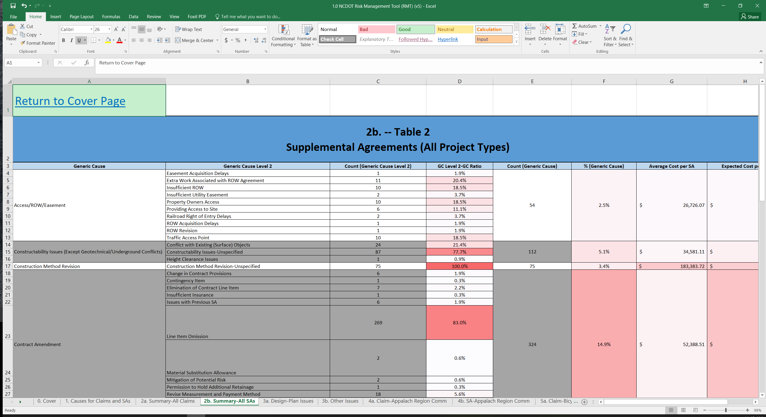

**Figure 5. Description of supplemental agreements for all project types.**

Figure 6. provides a description of Design/Plan Issues for claims and supplemental agreements. Note that Roadway Design issues were the cause of 14.4% of the claims, amounting to an average of $59,900 per claim, which is the highest amount of all the Design/Plan Issues categories. The main problem themes identified include noncompliance with paving regulations, drainage issues, delays in contract completion, poor quality materials, design issues, plan errors, utility relocations, material shortages, scheduling issues, guardrail installation and removal, and lack of ADA compliance. These issues caused extra work, delays, and additional costs for the contractor.

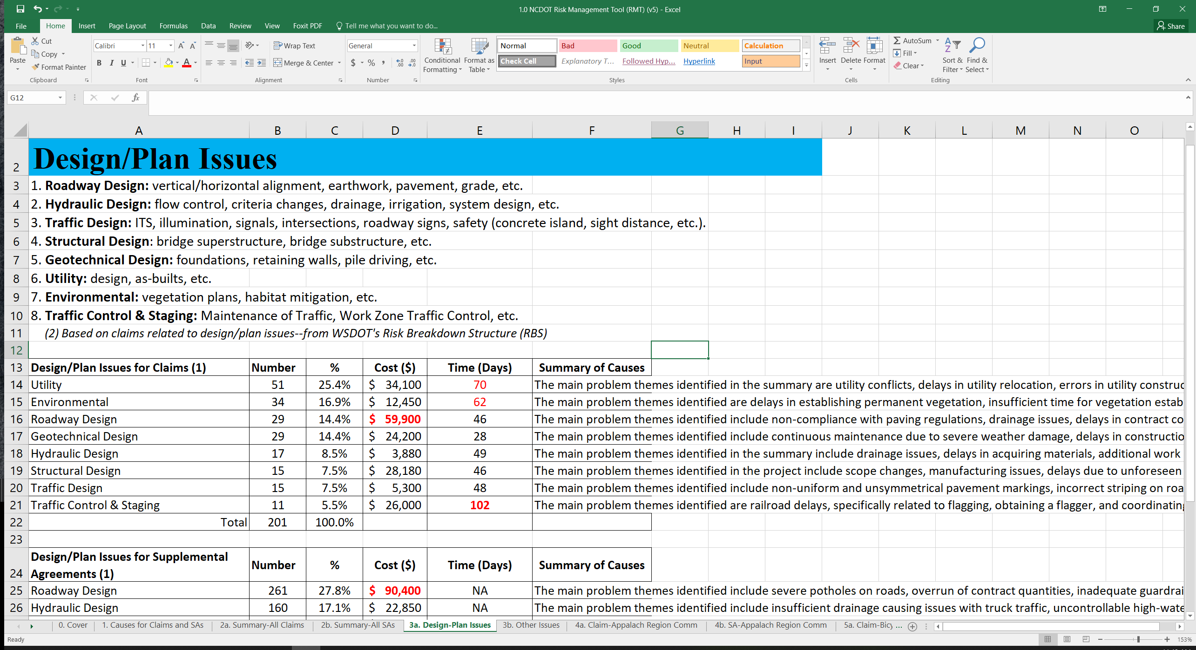

**Figure 6. Description of design/plan issues for claims and supplemental agreements.**

Figure 7 shows typical risk mitigation strategies related to utilities, categorized into four levels of information. The first level provides a diagram that depicts the main causes of risk (e.g., Relocation Delays), Key Questions (e.g., What is the best way to reduce utility delays?), and Mitigation Strategies (e.g., Establish an appropriate schedule prior to construction). Each of the other three levels provides a detailed breakdown of the information found in this diagram.

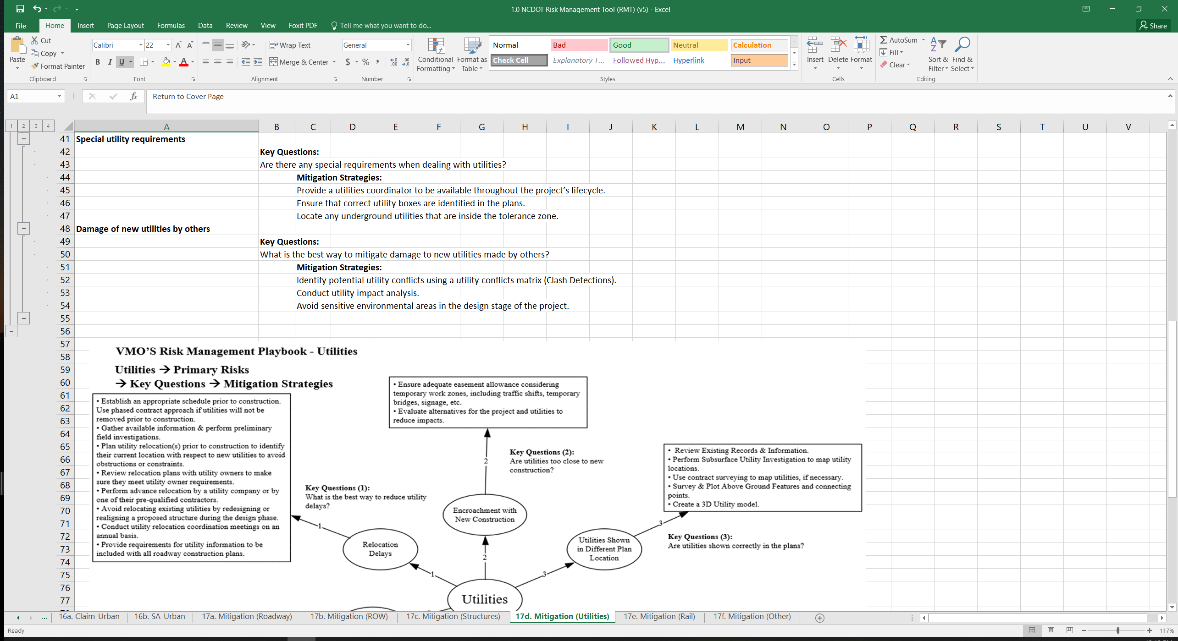

**Figure 7. Utilities risk mitigation strategies.**

## Use Cases

The primary use of the RMT is to assist the project management team in completing the NCDOT’s RAW. The RAW provides risk examples in different areas, such as long-range planning, environmental risks, regulatory risks, etc. These risks are generic and are not tailored to specific types of projects. For example, the risk profile for a bridge replacement project will differ from that of a ferry or highway safety project. The RMT can help project teams identify risks that are pertinent to their projects. Step 1 of the RMT is for the team to become familiar with the types of risks that are common to NCDOT projects. Step 2 allows the team to identify risks by project type (e.g., bridge replacement, urban, and rural), which are further broken down by claims and supplemental agreements. The RMT provides detailed information about which risks are more prevalent on a particular project as well as their cost and schedule impacts. Once risks are identified, the project team is provided mitigation strategies, as found in Step 3. The RMT will hopefully make it easier for teams to complete the RAW for their projects.

The RMT also can be used by other groups within the NCDOT. For example, estimators can search the level of risk on certain projects and apply appropriate levels of contingency factors. The NCDOT will be able to see more clearly the types of projects that can expect greater utilities conflict issues (e.g., urban vs. rural projects) and better understand risk and mitigation strategies for obtaining right-of-way, for example. Therefore, the NCDOT can be more proactive in addressing such issues using the mitigation strategies found in this tool.

# DESIGN RISK TOOL (DRT)

The NCSU research team developed the DRT by analyzing recent (2021 – 2023) claims and supplemental agreement data. The team analyzed approximately 1,800 claims and supplemental agreements to gain further insights related to Design/Plan issues and Other issues. Design/Plan issues are a significant cause for problems that arise during the construction phase. Claims and supplemental agreement summaries from the DRT are also provided in the RMT. The team used ChatGPT to provide summaries for all claims and supplemental agreements and generated word clouds to provide a graphic representation of common words found in the descriptions.

## DRT Description

The DRT provides three levels of detail for each design area as well as the Other category. Figure 8 is an image of the All Design Risks (Level 1) tab. Level 1 includes the following design areas: Pavement, Traffic, Hydraulic, Utility, Geotechnical, Roadway, Traffic Control and Staging, Environmental, and Structural. Level 1 also indicates a significant number of non-design-related Other issues that should be considered (e.g., inflation adjustments, material delay, COVID delay, etc.).

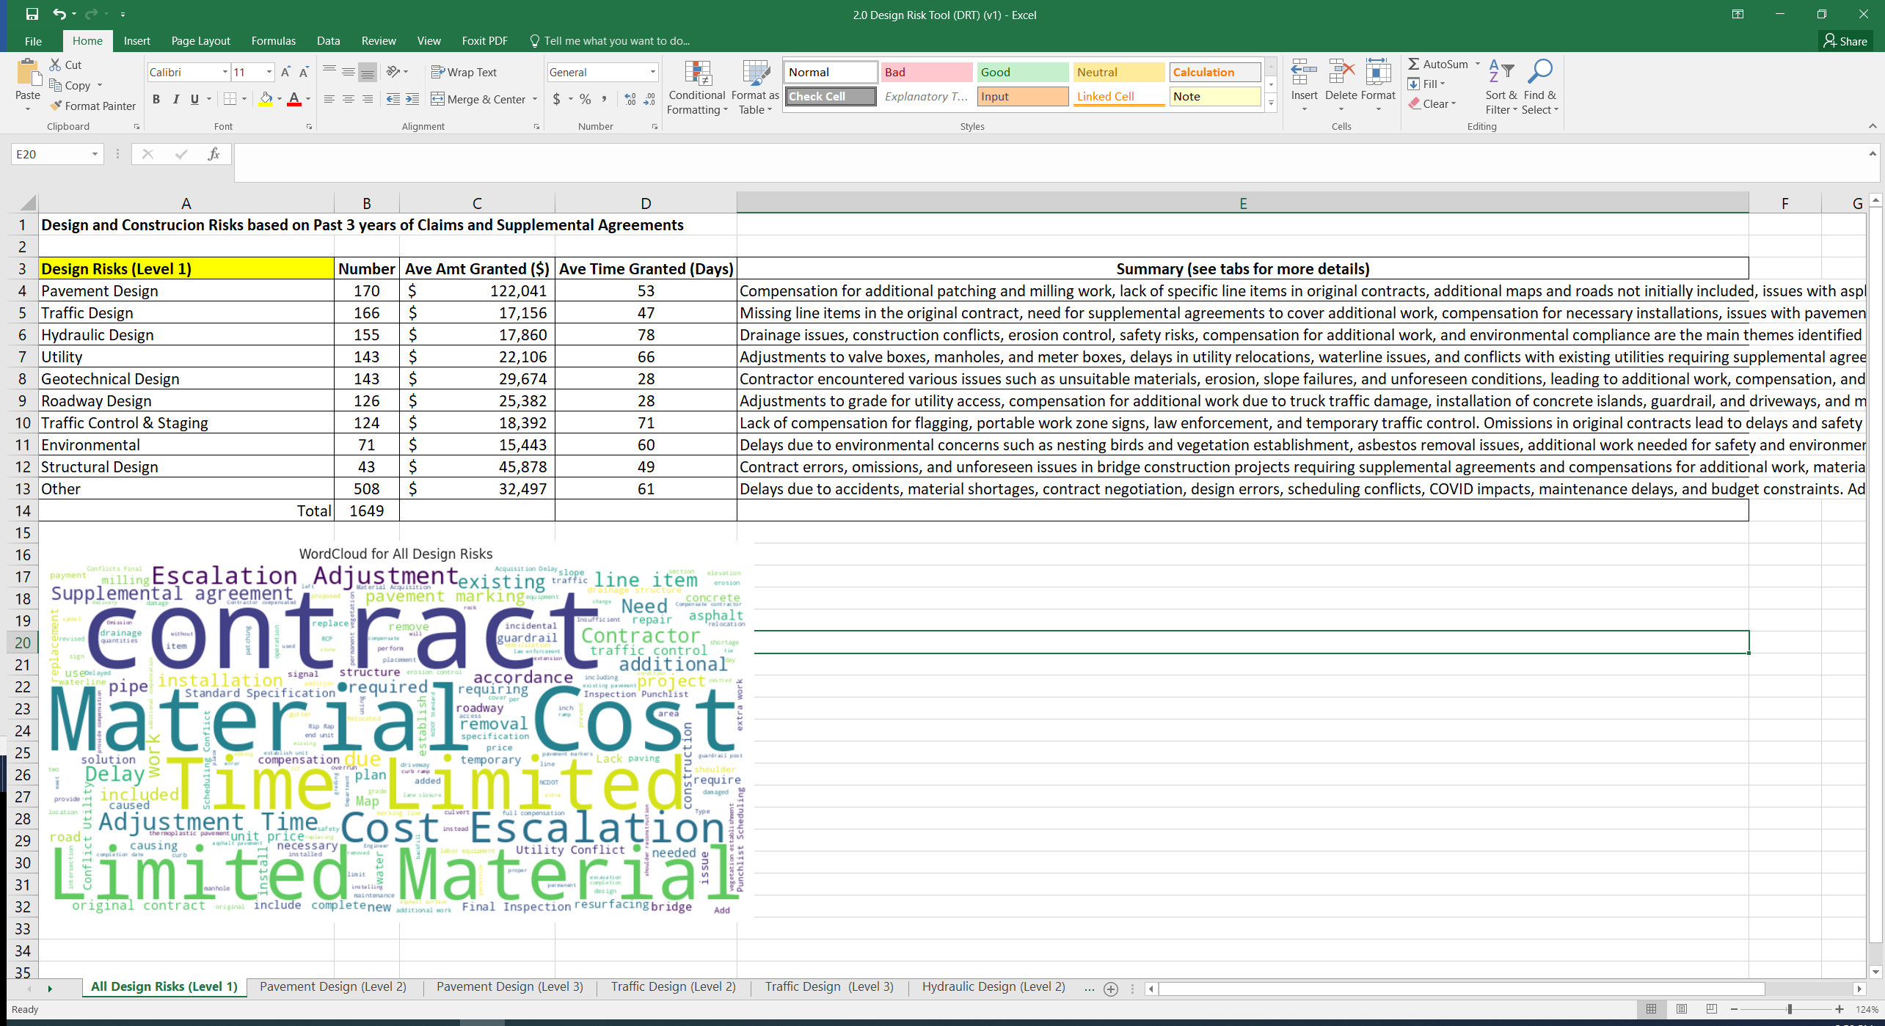

**Figure 8. Design Risk Tool: All design risks (Level 1).**

Figure 9 shows that Level 2 provides a breakdown of the main categories for each of the nine pavement design disciplines: plan revision, contract, drainage, paving, quality, construction, other project delay, specifications, and underlying layer.

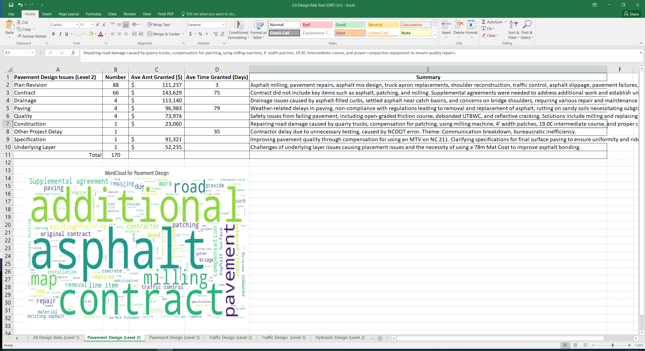

**Figure 9. Design Risk Tool: Pavement design (Level 2).**

Figure 10 shows that Level 3 includes a summary of the actual claim or supplemental agreement. Thus, each design area includes two levels of detail that can provide project managers with complete information about past projects.

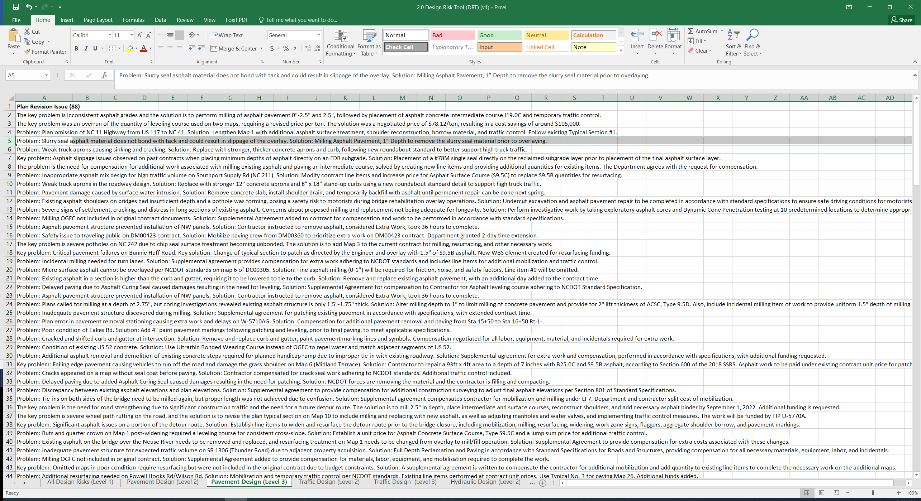

**Figure 10. Design Risk Tool: Pavement design (Level 3).**

## Summaries of DRT Design/Plan and Other Issues

Figure 11 shows the design areas with the highest percentage of problem occurrences that pertain to Roadway, Utilities, Hydraulics, and Traffic design, broken down by claims and supplemental agreements. Figure 12 shows that Roadway has the highest cost per occurrence for both claims and supplemental agreements, followed by Structural design supplemental agreements.

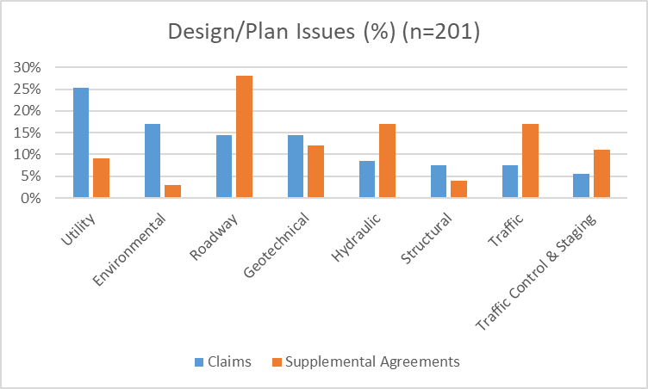

**Figure 11. Percentages of design/plan issues for claims and supplemental agreements.**

**Figure 12. Costs of design/plan issues for claims and supplemental agreements ($/occurrence).**

The DRT subsequently provides detailed descriptions of Design/Plan issues for both claims and supplemental agreements in each of the main design areas. The following information outlines the main problem themes identified. Note that the more significant problematic areas are highlighted in red.

**Roadway Design**

* **Claims:** Issues include noncompliance with paving regulations, drainage issues, delays in contract completion, poor quality materials, design errors, plan errors, utility relocations, material shortages, scheduling problems, guardrail installation and removal, and lack of ADA compliance. These issues caused extra work, delays, and additional costs for the contractor.
* **Supplemental agreements:** Issues include severe potholes on roads, overrun of contract quantities, inadequate guardrail protection, deteriorating pavement, inconsistent asphalt grades, missing line items in the contract, and the need for additional compensation for extra work and materials. Other issues include inadequate tie-downs, insufficient guardrail coverage, and the need for additional asphalt surface treatment. The solutions involve creating supplemental agreements, establishing unit prices, and providing compensation for extra work and materials.

**Hydraulic Design**

* **Claims:** Issues include drainage issues, delays in acquiring materials, additional work required by environmental officers, obstruction of work by other projects, collapsed drainage structures, and missing line items in the contract. These issues caused delays and extra work for the contractor and, in some cases, compensation was required for additional materials or work not included in the original contract.
* **Supplemental agreements:** Issues include insufficient drainage that caused problems with truck traffic, uncontrollable high-water levels, lack of proper drainage and uneven pavement at proposed roundabouts, drainage concerns on bridge shoulders, availability issues with ductile iron pipe, and the need for additional drainage work, including masonry structures, HDPE pipes, concrete islands, borrow excavation, rip-rap, seeding and mulching, flaggers, and temporary traffic control. Other issues include problems with existing pipes, catch basins, and drainage structures that required repair or replacement, as well as the need for erosion control measures such as wattles and turbidity curtains. Further, items omitted from the original contract led to supplemental agreements for compensation and additional work.

**Traffic Design**

* **Claims:** Issues include non-uniform and unsymmetrical pavement markings, incorrect striping on roads, incomplete permanent pavement markings, sight distance design errors, delay in approval of installations, inadequate pavement markings, and the use of non-ADA compliant material. Low visibility of crosswalks and temporary paint required additional measures, and missing line items caused compensation issues.
* **Supplemental agreements:** Issues include missing line items in the contract for necessary work, inadequate pavement markings, insufficient compensation for additional work, damaged or missing equipment, and safety concerns. Solutions include establishing pricing for additional work items, revising plans to account for traffic, compensating for necessary equipment and materials, and installing new pavement markings and safety features.

**Geotechnical Design**

* **Claims:** Issues include continuous maintenance due to severe weather damage, delays in construction due to various problems, including high-water levels and unexpected subsurface conditions, poor quality materials, and the need for shoring to prevent erosion and exposure of graves during excavation. Solutions include using sheet piling as coffer dams, improving material quality, and extending contract completion dates.
* **Supplemental agreements:** Issues include slope failure, contaminated soil, unexpected rock, poor soil conditions, erosion issues, inadequate contract planning, omission of payment for necessary materials, unstable toe of slope, and lack of established line items for necessary work. Solutions include compensation for necessary materials and labor, installation of geotextile fabric and rip-rap, and additional mobilization for necessary work.

**Traffic Control and Staging**

* **Claims:** Issues include railroad delays, problems specifically related to flagging, obtaining a flagger, and coordinating with the railroad company. Other issues include overlooked work zone signs, modifying barricades, and safety concerns related to the absence of truck-mounted attenuators. Payment for railroad inspectors and compensation for delays also were problematic.
* **Supplemental agreements:** Issues include the need for portable changeable message signs, type E sign erection, removal, and relocation, U-channel support disposal, and 3-lb steel U-channel supports. Lack of compensation for various traffic control measures, such as flaggers, law enforcement, and temporary traffic control devices, also caused problems as well as plan omissions, conflicting pavement markings, and the need for additional safety measures.

**Utilities**

* **Claims:** Issues include utility conflicts, delays in utility relocation, errors in utility construction plans, unexpected waterline replacements, and delays caused by power company responses. These issues caused delays in the completion of the project, additional materials and grading, erosion measures, and idle equipment-related costs for the contractor. Thus, additional compensation was requested for idle equipment and revised completion dates were set.
* **Supplemental agreements:** Issues include utility conflicts, need for compensation for extra work and materials, incorrect or omitted information on plans, damage to existing infrastructure, and delays in utility relocations. These issues involved water and sewer line relocation, fire hydrant and meter adjustments, manhole and valve adjustments, and exploratory excavation to locate utilities. Supplemental agreements and compensation were necessary to address these problems.

**Structural Design**

* **Claims:** Issues include scope changes, manufacturing issues, delays due to unforeseen circumstances, errors in plans and specifications, and additional costs incurred for materials and labor. The contractor was not at fault for some of the issues, but improvements in manufacturing and planning processes are needed to prevent future problems.
* **Supplemental agreements:** Issues include bridge approach paving, overstress in spans, concrete slab failure, missing bridge items, compensation for additional work and materials, plan errors, guardrail installation, and structural deficiencies. These issues resulted in delays and increased material costs, and required supplemental agreements to address the additional work and compensation**.**

**Environmental Design**

* **Claims:** Issues include delays in establishing permanent vegetation, insufficient time for vegetation establishment, unfavorable weather conditions, and contractor compensation problems. These issues caused delays in completing the contract and meeting erosion control requirements. Additional drainage infrastructure and wildlife nesting also caused delays. Recommendations include adding 180 days to the original completion date and granting time for the contractor to attain 80% permanent cover.
* **Supplemental agreements:** Issues include trees marked for removal instead of saving, asbestos removal, lack of permanent vegetation establishment, insufficient vegetative coverage, damaged asphalt and vegetation, missing line items in the contract, and non-native plant material. These issues required additional work and compensation to ensure compliance with regulations and project specifications.

In addition to Design/Plan issues, the DRT also includes Other issues that typically are non-design-related and include problems such as delays in final inspections and punch lists, delays in contract execution, material acquisition delays, time-limited material cost escalation adjustments, missing line items in contracts, additional work requested, and extensions of maps that can lead to overruns in contract amounts. Other issues also include damage to structures and problems related to equipment mobilization and traffic control. The following information outlines the main problem themes identified for Other issues. The more significant problematic areas are highlighted in red.

**Other Issues**

* **Claims:** Issues include delays in project completion due to incomplete previous projects, pandemic-related shutdowns and staffing shortages, delays in material acquisition, waiting for other entities to perform work, scheduling conflicts, delays in final inspections and punch lists (12%), and delays in contract execution (2%). Delays also were caused by additional work, equipment malfunctions, and errors in sign fabrication.
* **Supplemental agreements:** Issues include material acquisition delays (12%), time-limited material cost escalation adjustments (46%), missing line items in contracts, additional work requested, and extensions of maps that led to overruns in contract amounts. Other issues include damage to structures, equipment mobilization, and traffic control.

## Use Cases

The DRT should be of particular interest to the various design groups within the NCDOT as a tool that can help proactively identify potential design errors and omissions before construction begins. For example, Roadway supplemental agreements are the highest impact area from a cost perspective (~$90,000 per occurrence; see Figure 12). The DRT allows the roadway design team to delve deeper into the causes of this significant cost impact. A description at Level 1 shows that

**t**he main problem themes identified include severe potholes on roads, overrun of contract quantities, inadequate guardrail protection, deteriorating pavement, inconsistent asphalt grades, missing line items in the contract, and the need for additional compensation for extra work and materials. Level 2 shows that ‘plan revision’ and ‘contract issues’ are the areas of most concern. Plan revisions include contract discrepancies that involve problems with maps, concrete sidewalks, guardrails, and road elevations. Modifications, additional funding, and compensation were required to address the discrepancies and ensure compliance with NCDOT standards. Contract issues include expansion of the scope to include additional work, such as guardrail placement, driveway reconstruction, and curb ramp installation. Various items that were not originally included in the contract required supplemental agreements for compensation and adjustments. Level 3 provides details regarding the actual claim and supplemental agreements. This information can provide the necessary insights for designers to check their designs for these potential issues, thus averting a potential change during the construction phase.

# FEEDBACK

The NCSU research team conducted this technology transfer project under the guidance of the NCDOT VMO team who provided feedback throughout the course of the project. Based on the VMO’s feedback, the research team made improvements to existing risk management tools (the RIT and RMP) that are reflected in the new RMT and DRT. These new tools were demonstrated to one NCDOT project manager who responded positively regarding the kind of risk insights that could be gleaned from these materials. Additional feedback from other project managers should be considered under future work.

# POWER BI VERSION OF THE NEW RMT AND DRT

As an added bonus for this technology transfer project, the NCSU research team developed a Power BI tool that extracts the most important elements from the RMT and DRT to facilitate user friendliness. This Power BI version simplifies and streamlines the access of risk information by reducing the number of tabs from 59 to 7, which are as follows: Introduction, Generic Cause (Cost Impact 1993-2021), Specific Cause (Cost Impact 1993-2021), Discipline Breakdown (2021-23), Discipline Breakdown by Subcategory (2021-23), and Mitigation Strategies. This new streamlined tool, referred to as the Integrated Risk Management Tool (I-RMT), includes information from the Excel-based RMT and DRT, with the exceptions of Level 3 detail in the DRT and the Key Questions and the graphic related to risk mitigation strategies. I-RMT is more compact than the RMT and DRT as it takes advantage of Power BI’s filtering and slicing features. I-RMT can be viewed directly using the Power BI Desktop (free download) or through the Power BI Service once the necessary workspace is created.

Figure 13 shows the cover tab that describes the background and purpose of the I-RMT. Figure 14 reveals the Generic Causes for risks, which includes slicers for the category (claims or supplemental agreements) and project type.

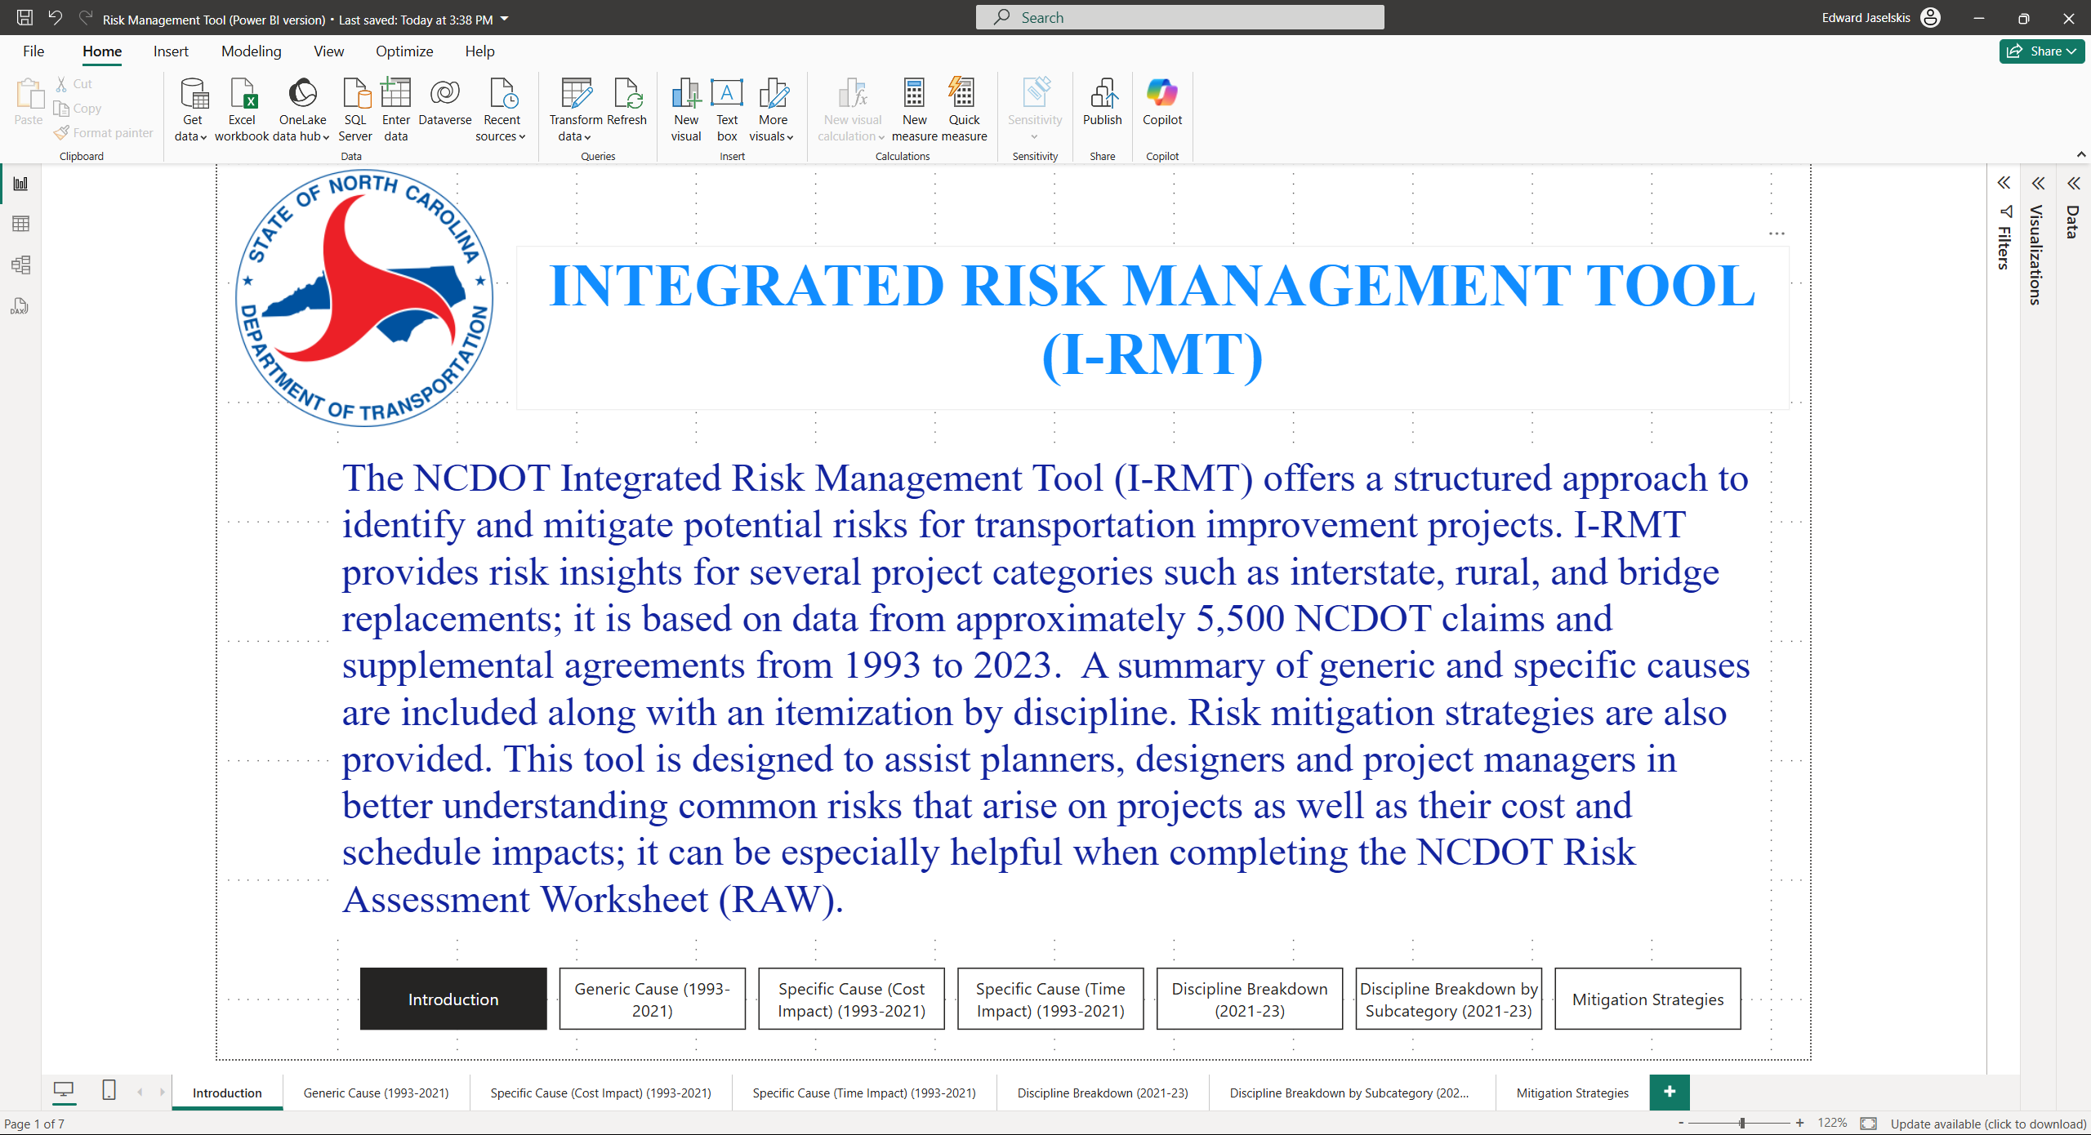

Figure 13. Introduction to the Integrated Risk Management Tool (I-RMT).

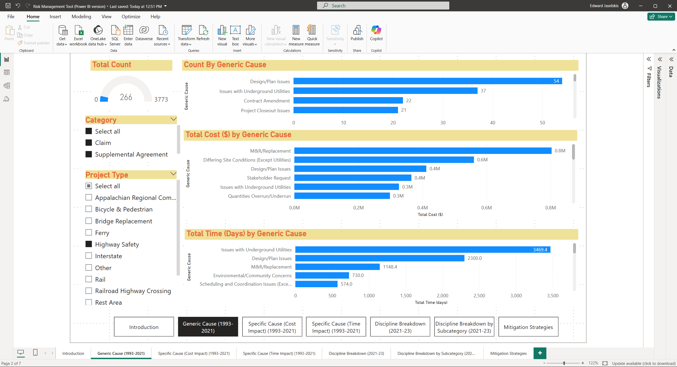

Figure 14. I-RMT: Generic Causes with slicers by category and project type.

In the I-RMT, risk information is provided according to Discipline, referred to as Design/Plan issues in the DRT. Figure 15 shows a Discipline breakdown by area (e.g., Structural, Hydraulic, and Traffic Design) and provides the average cost and time for each area.

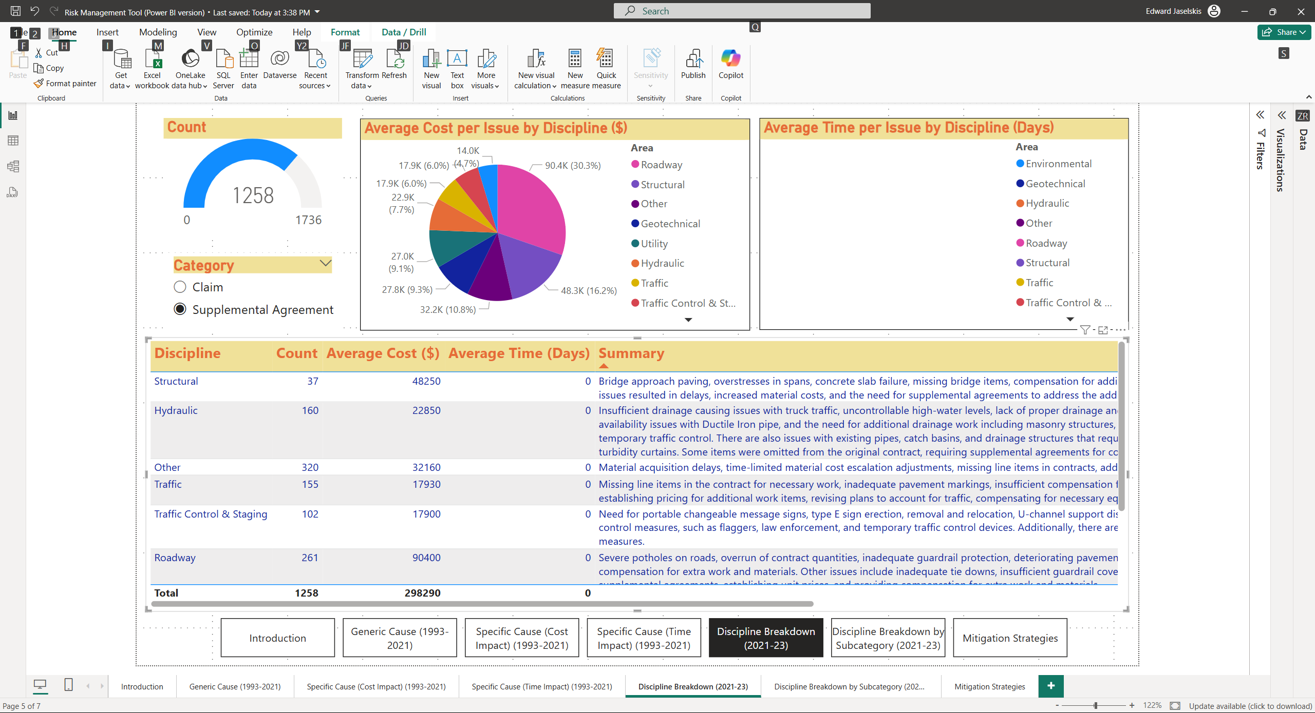

Figure 15. I-RMT: Discipline area breakdown showing average cost and time.

# SUMMARY AND CONCLUSION

In this technology transfer project, the NCSU research team developed a more streamlined version of the previously developed RIT and RMP, Risk Management Tool (RMT), which includes a description of the risk assessment process starting with becoming familiar with risks on NCDOT projects (Step 1), identifying risks by project type (Step 2), and identifying risk mitigation strategies (Step 3). A new Design Risk Tool was also created using newer claims and supplemental agreements (2021-2023). In addition, the team created a unified Power BI version of the RMT and DRT, referred to as I-RMT (Integrated Risk Management Tool), to provide a more streamlined user experience. I-RMT is a more compact version of the two Excel tools that reduces the number of navigation tabs from 59 to 7. I-RMT can be viewed directly using the Power BI Desktop (free download) or through the Power BI Service once the necessary workspace is created. Figure 16 shows the progression of the development process for the risk tools described in this report.

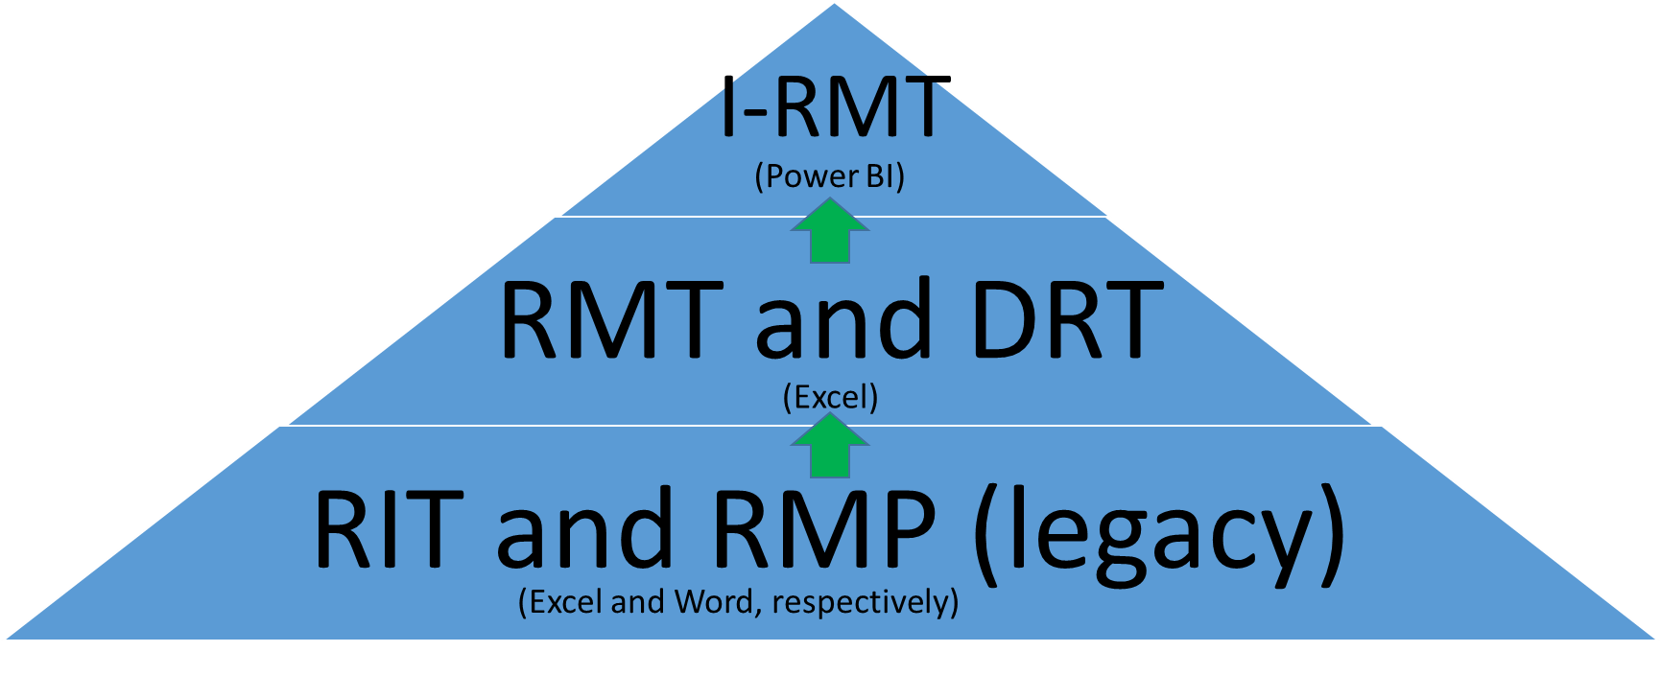

Figure 16. Progression of risk tool development.

Either the Excel versions or Power BI version of these risk management tools can be used by multiple stakeholders in the NCDOT (e.g., designers, project managers, and estimators) to identify and mitigate project risks, thus reducing the chance of a claim or supplemental agreement. These tools offer project teams a structured approach to identify and address potential risks at each project stage, ultimately leading to better risk management outcomes. The tools can be integrated into the NCDOT's formal risk management program and the identified mitigation strategies can be added to the Communicate Lessons, Exchange, Advice, Record (CLEAR) program, which is a SharePoint platform used at the NCDOT to collect employee-generated ideas, best practices, and lessons learned.

Further research can explore ways to broaden the use of the newly developed tools, such as their integration with the NCDOT’s Risk Assessment Program and/or the adoption of artificial intelligence to create a risk identification/mitigation chatbot that is fine-tuned to address NCDOT project issues. Additional user feedback should be obtained to better understand user preferences about ways these tools should best be implemented within the NCDOT. The current versions of these tools are expected to be sufficient for NCDOT users to help identify and mitigate claims and supplemental agreements on future projects.

# REFERENCES

Federal Highway Administration. *Risk Management Guidance*. United States Department of Transportation, 2016.

Herrera, R. F., O. Sánchez, K. Castañeda, and H. Porras. Cost overrun causative factors in road infrastructure projects: A frequency and importance analysis, *Applied Sciences,* 10(16): 5506, 2020.

Jaselskis, E. and J. Leca. *Analysis of Current Risk Assessment Programs of State Departments of Transportation.* Final Report, North Carolina Department of Transportation, September 2019.

Jaselskis, E. and S. Gholami. *Expanding the NCDOT’s Current Risk Management Program*. North Carolina Department of Transportation, Report FHWA/NC/2021-16, May 2023.

Maytorena, E., G. M. Winch, J. Freeman, and T. Kiely. The influence of experience and information search styles on project risk identification performance, *IEEE Transactions on Engineering Management,* 54(2): 315-326, 2007.

Ofori, G. Construction economics: Its origins, significance, current status and need for development. In *Research Companion to Construction Economics*, Edward Elgar Publishing, 2022, 18-40.

NCDOT Value Management Office, <https://www.ncdot.gov/about-us/board-offices/offices/value-management/Pages/default.aspx>, 2025.

Project Management Institute, Inc. A Guide to the Project Management Body of Knowledge (PMBOK Guide) (6th ed.), 2017.

Siraj, N. B. and A. R. Fayek. Risk identification and common risks in construction: Literature review and content analysis, *Journal of Construction Engineering and Management,* 145(9): 03119004, 2019.

U. S. Census Bureau. *Monthly Construction Spending*, May 2023. [Online]. Available: https://www.census.gov/construction/c30/pdf/release.pdf. [Accessed 23 May 2023].

U.S. Department of Energy. *Project Management Practices: Risk Management*, 2003.